Readme Gasoline taxes

Overview:

There are two dofiles.

* “gasoline_clean” (in the raw folder)
  + Creates gasprices.dta: pretax gasprices
    - Imports annual cpi for gasoline
    - Imports gasprices up to and including 2010 and cleans it
    - Replace missing values for DC with average of Maryland and Virginia
    - Approximates gas prices for years after 2010 using the annual cpi numbers.
  + Creates gasoline_taxes.dta: excise tax in cents per gallon of gasoline, by state and year.
    - Imports excel document with numbers copy pasted from the book of states
* “gasoline”:
  + Creates “gas_taxes_paid`year'.dta”
    - This script combines excise taxes, gas prices and sales tax rates to estimate linearized tax rates per state. It then uses the CE-tables to calculate the estimated gasoline taxes paid per household, by state and income category.
    - Note: the income categories are not harmonized over years.

There were some issues in calculating the gasoline taxes, as explained in an email sent January 21st 2022. A summary below:

Gasoline excise tax

The retail prices for gasoline are only available up until 2010. I have used the cpi for gasoline to get the prices for later years.

With my estimations, I could replicate the figure 23 in the paper, which is for 2005/2006. The only exception is Ohio. The figure includes Ohio among the sales taxable states, but I believe this is a mistake. In the book of states (picture below), it says that there is a “plus 3 cents commercial” in Ohio, but not that gasoline is sales taxable, like the other states in footnote 34. It also seems that Ohio is not included as a sales taxable state in the dataset which is used for the Tau-estimation. All taken together, this suggests that figure 23 and footnote 34 in the paper is not up to date.

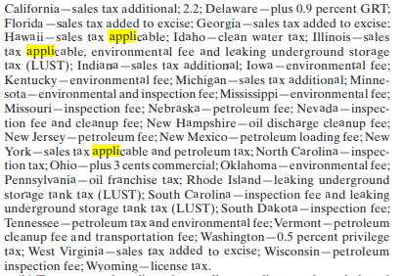

Using the same code, I was not able to replicate the results for 2010/11 and 2015/16. I get the same results for the states in which gasoline is not sales taxable. For the states in which gasoline is sales taxable however, I get tax rates that are 5-11 percentage points higher. I have checked the inputs that Sarolta most likely has used to produce her tax rates, and we are using the same numbers. If this is true, then we must be calculating the rates for these states differently, which is strange given that I am applying the same method as in 2005/06. I have not seen this discussed in the appendix in the paper, so I do not expect that a different method was applied for the different years.

I believe my estimations are “correct”, but it depends on the assumptions made. You should yourself the following questions:

* Is there a good reason to approximate the taxrates for sales taxable states differently in 2005/06 than in 2010/11 and 2015/16? My method is the same across years.
* Should the sales taxable states be treated the same? I have done this, but this may be a simplification (see discussion below)
* Should the sales taxable states be the same across time? I have done this, but there is slight variation over time as well (see discussion below).

An additional comment:

As you can see in the picture above, there are some nuances in how gasoline is sales taxable in the different states. For instance, in 2011 the states had the following description:

Sales tax additional:

"California", "Indiana", "Michigan"

sales tax applicable:

"Hawaii", "Illinois", "New York"

Sales tax added to excise:

"Florida", "Georgia", "West Virginia"

Also, some states change status throughout the period. For instance, in 2015, California now labeled as “Includes pre-paid sales tax”. It is not clear for me how this affects how this is calculated. Did you take this into account when calculating the rates for California? I have not. Other than California, there are instances of states changing category, but I have not seen any states drop out of or join the set of the sales taxable categories (“Sales tax additional”, “sales tax applicable” and “Sales tax added to excise”).

I have not been able to find the definition of these categories, so I have not been able to learn the precise difference. It might be fine to treat them all the same, as it seems might have been done so far, but I just want you to be aware of this.